**Name:- Samreen Shaikh Roll no:- 64**

**Subject:- Big Data Analytics Date:- 21/02/2025**

**PRACTICAL - 15**

**HBASE INSTALLATION AND OPERATIONS**

**INSTALLATION**

**STEP I : *PRE-REQUISITES***

**a) Check if JDK Version 1.8 is installed in your system.**

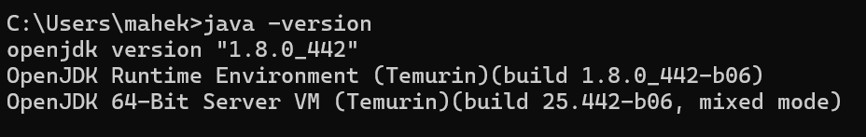

**b) Install hive from the link given below and extract it in C drive.**

**<https://archive.apache.org/dist/hbase/2.2.5/>**

**STEP II: *Navigate to “C:\hbase-2.2.5\bin\hbase.cmd” in any text editor these lines should exactly look like this.***



**STEP III: *Navigate to “C:\hbase-2.2.5\conf\hbase-env.cmd” and add the highlighted part below the comments.***

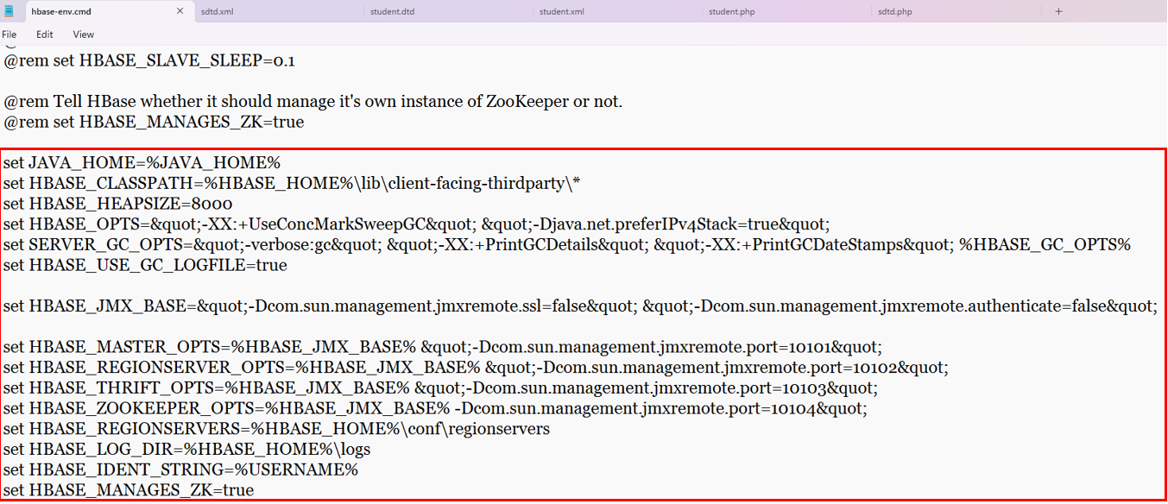

**STEP IV: *Navigate to “C:\hbase-2.2.5\conf\hbase-site.xml” and add the highlighted part below.***

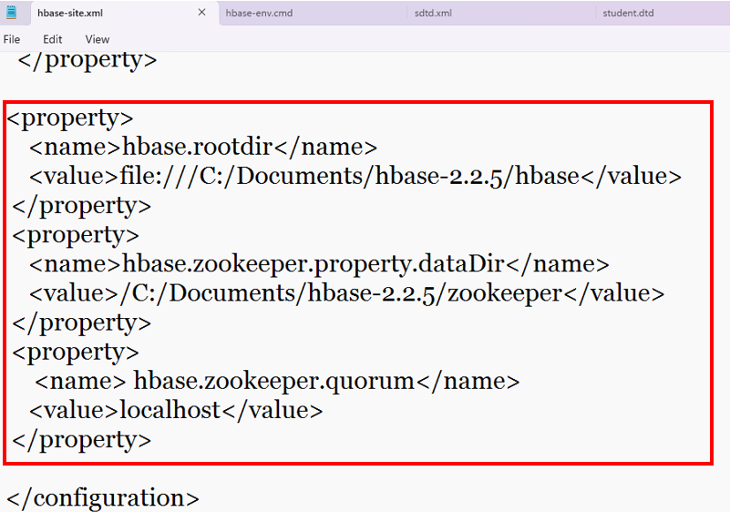

**STEP V: *Now set HBASE_HOME Path in System Variables and in its path.***

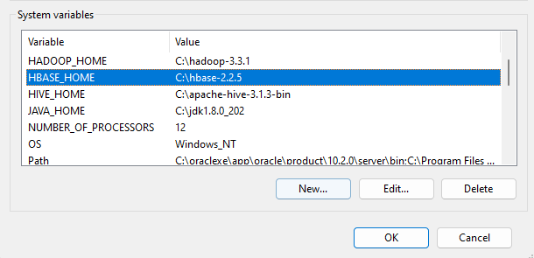

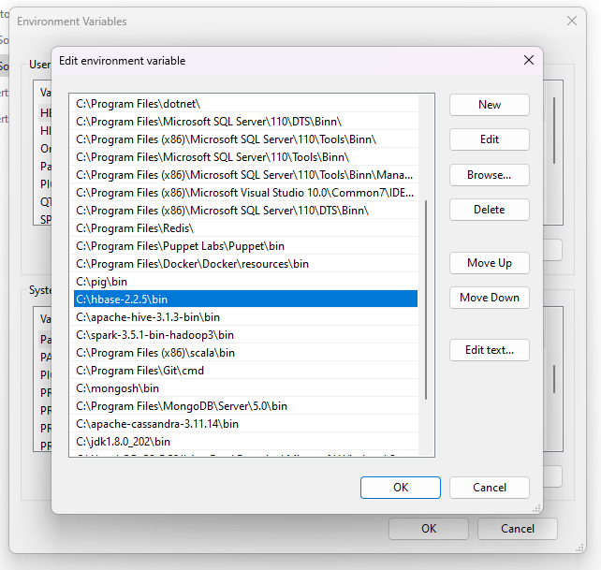

**STEP VI: *Navigate to ‘bin’ folder of hbase start the command prompt there and type the command: start-hbase.cmd***

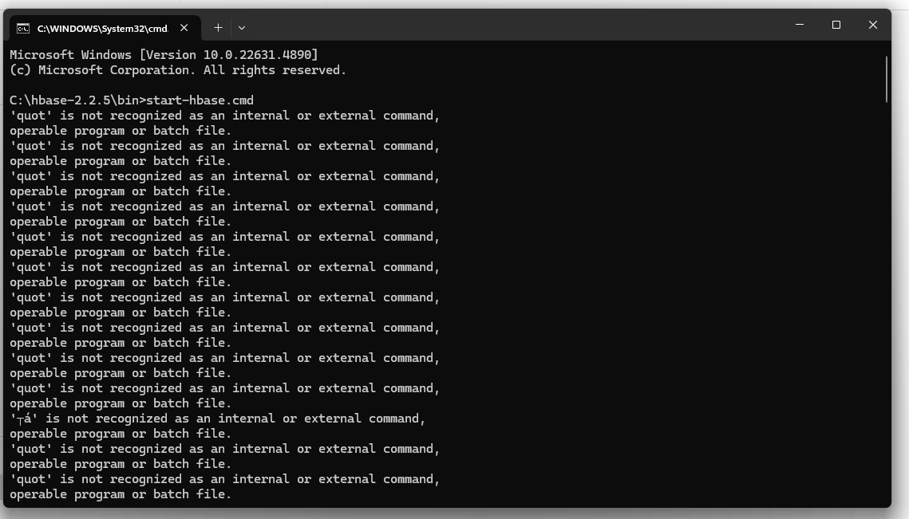

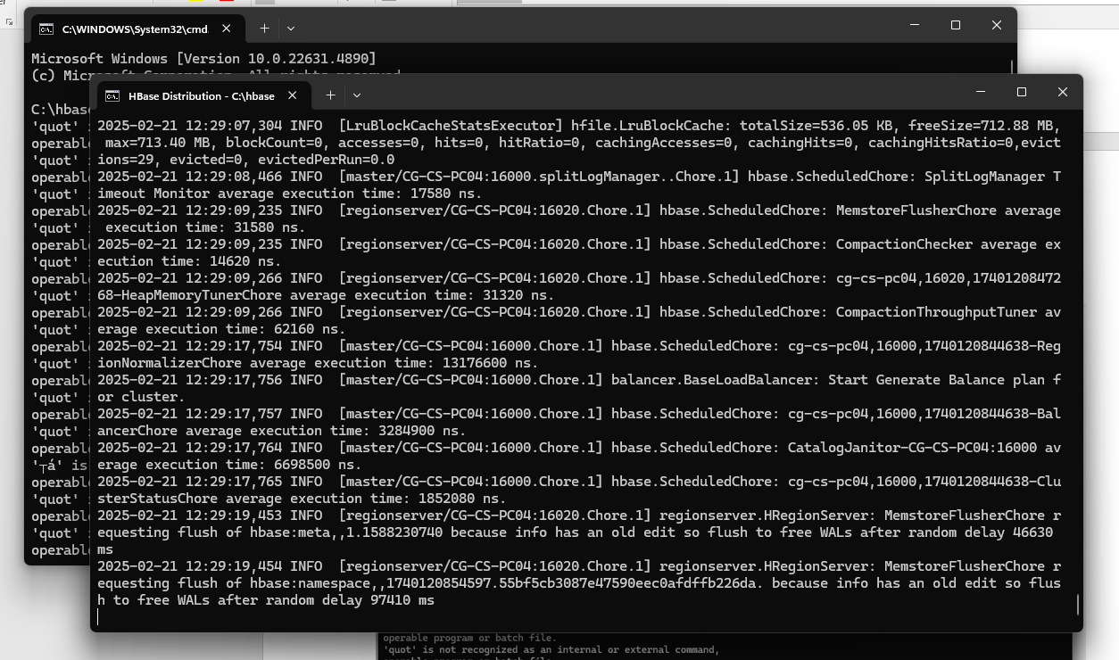

**STEP VII: *Again navigate to ‘bin’ folder of hbase start the command prompt there and type the command: hbase shell***

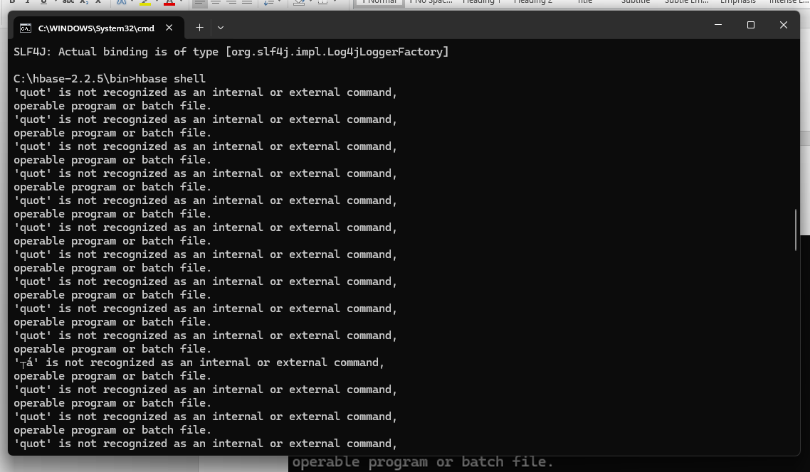

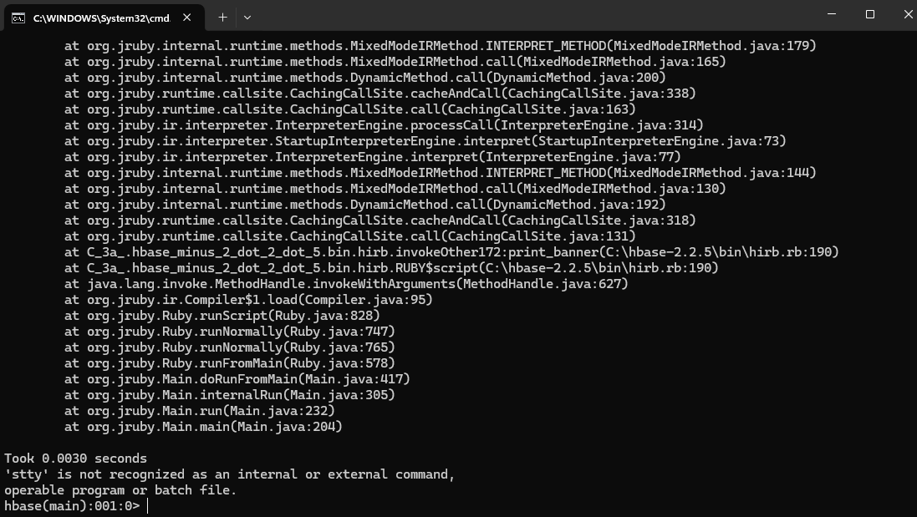

**OPERATIONS**

**1] Status**



**2] Status simple**

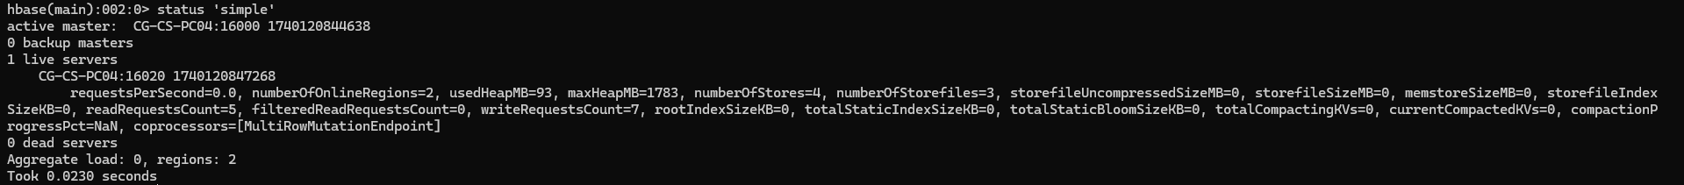

**3] Whoami**



**4] Create table ‘kccs’.**

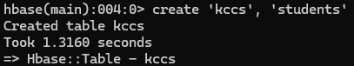

**5] List tables**

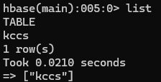

**6] Describe table ‘kccs’.**

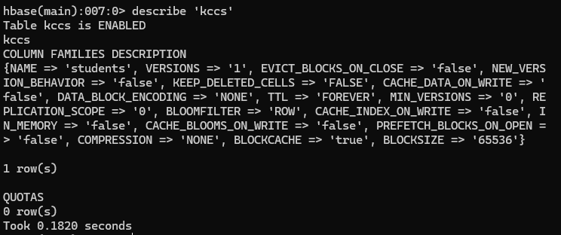

**7] Disable table ‘kccs’**



**8] Describe table ‘kccs’ again to see disabled status.**

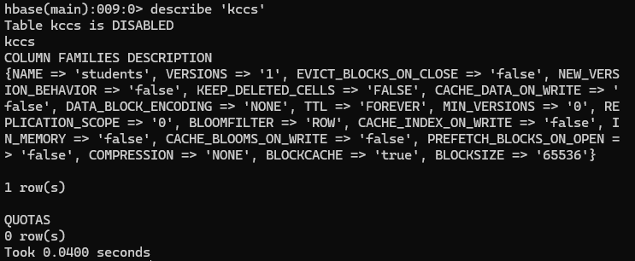

**9] Enable table ‘kccs’.**



**10] Show_filters**

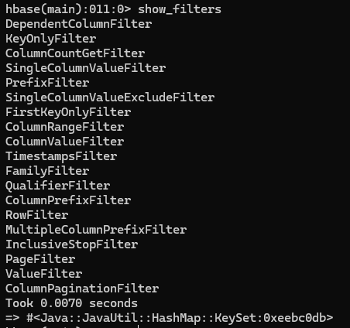

**11] Drop table.**

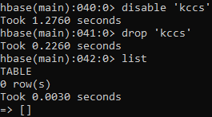

**12] Alter table ‘kccs’ adding name of the teachers.**

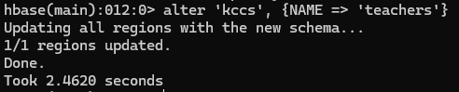

**13] Count rows ‘kccs’.**

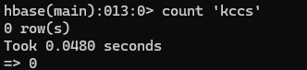

**14] Put values in table ‘kccs’.**

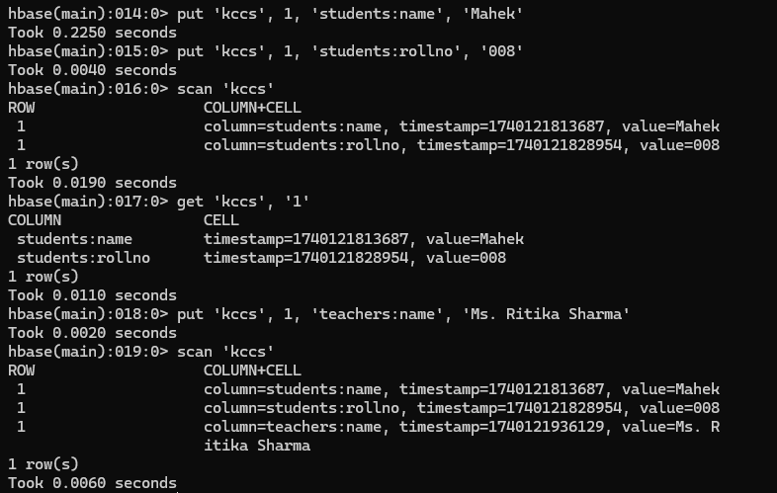

**15] Scan values in table ‘kccs’**

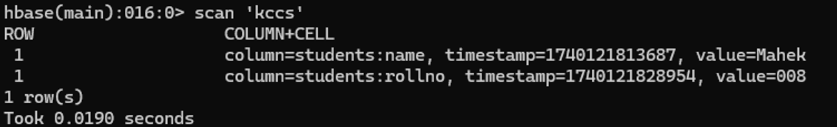

**16] Get specific value in table ‘kccs’**

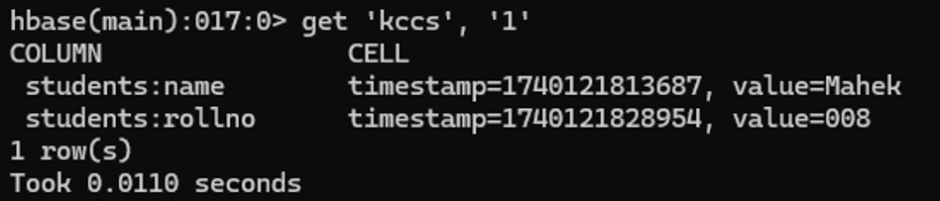

**17] Put and scan teachers name in table ‘kccs’.**

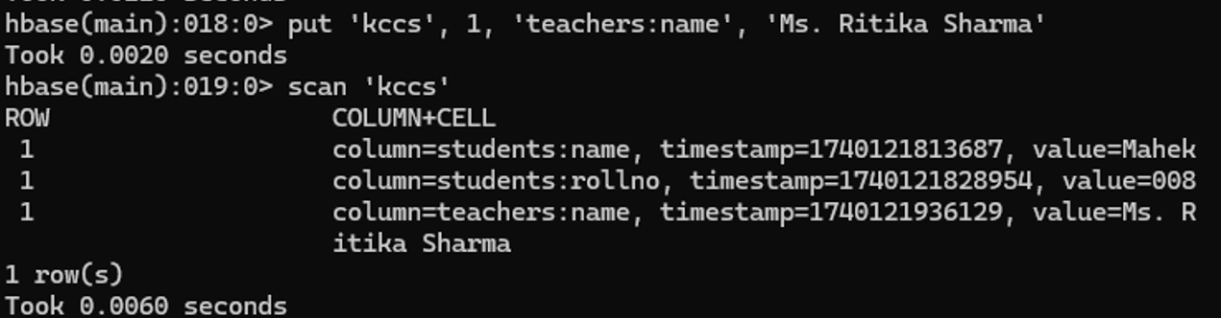

**18] Get values of table ‘kccs’.**

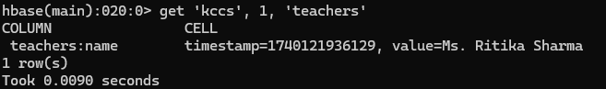

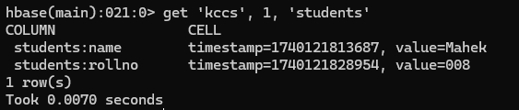

**19] Delete values in table ‘kccs’.**

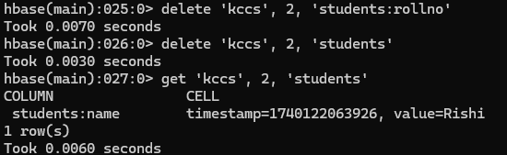

**20] Truncate table ‘kccs’.**

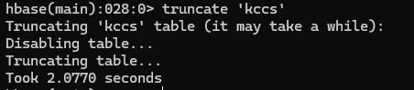

**21] Scan table ‘kccs’.**

